Sample text: Picture description +routines
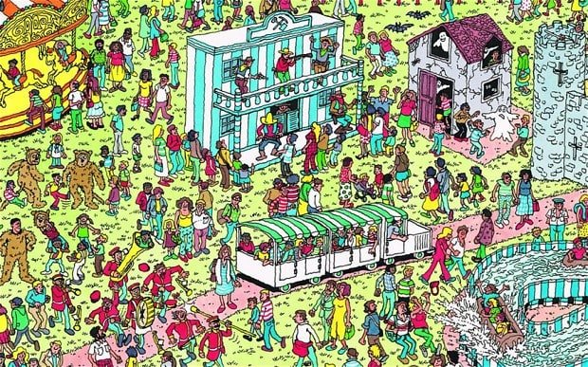
This is a theme park. There are lots of people. Three men are wearing bear fancy dresses today. They usually work in the entrance and they wear a suit. Some boys are sailing in a wood log, they are students and they are usually at school on weekdays. There is a Haunted House for the visitors. One of the ghosts is getting scared. He often feels calm but today there are many people. The band usually play wonderfully but today they are making a lot of noise. The drummer player is hitting a mate very hard so the man is falling onto the ground. The director isn’t concntrated and he is hitting a trumpet player. The trumpet is falling onto the ground. The children usually behave well but today, some of the kids are pulling the tail of the bear man and one young child is kicking an other bear man.The other children are laughing at the situation.

- Present continuous in blue.
- Present simple in black

